User Template Engine – System Manual (Odoo 19)
Oct 17, 2026 · @ibrahim
This manual explains how to install, configure, operate and support the User Template Engine module on Odoo 19. It is written for Odoo administrators, functional consultants and support staff; section 11 adds the technical reference and the differences from the Odoo 18 edition.
Item | Value
Module name | User Template Engine
Technical name | base_user_template_engine
Version | 19.0.1.0.0
Odoo version | 19.0, Community and Enterprise
Dependencies | base, web
Author | Ibrahim Yahia (LinkedIn)
License | LGPL-3
Conventions used in this manual
- Bold marks a button, menu, tab or field exactly as it appears on screen.
- Menu paths are written with arrows: Settings → Users & Companies → User Templates → User Templates.
- Template always means a record of the module's User Template model, not Odoo's standard "Default User Template".
- Administrator means a user whose Role is Administrator on the user form (Odoo 19's name for the former Settings right).
- Group names are written as Odoo 19 shows them, e.g. Export / Allowed, Contact / Creation.
- Screenshots were taken in Odoo 19 with the module's demo data installed.

1. Introduction
The User Template Engine provisions Odoo users from layered, reusable templates of preferences and access rights. Administrators group users with tags, and templates aimed at those tags are applied automatically or in bulk, with a preview and a full audit trail.

1.1 The problem in standard Odoo
Area | Standard Odoo 19 | With User Template Engine
New user access | Every new internal user gets the default groups and a Role (User or Administrator) | Any number of templates, chosen per user by tags or explicit assignment
Grouping users | No way to group users by team or role | User tags, editable from the user or from the tag
Reuse | Each access profile is rebuilt from scratch | Templates inherit settings from a parent, across several levels
Preferences | Language, time zone and companies are set user by user | Templates set them, with merge or override per setting
Bulk changes | No preview, no record of who changed what | Dry-run preview and an application log
Safety | Admin rights or user type can be broken by mistake | User type groups and admins are protected automatically

1.2 What the module manages
A template can manage seven settings of a user:
Setting | User field in Odoo 19
Language | Language (lang)
Timezone | Timezone (tz)
Home Action | Home Action (action_id)
Allowed Companies | Allowed Companies (company_ids)
Default Company | Default Company (company_id)
Access Groups | Explicit groups (group_ids)
Revoked Groups | Explicit groups (group_ids), removed
Odoo 19 separates a user's explicit groups (group_ids) from their effective groups including implied ones (all_group_ids). The module edits explicit groups and judges changes by effective groups; section 8.4 explains why.

1.3 Scope
The module does not change the standard Odoo user form beyond adding a Templates & Tags tab and a tags column. It never changes a user's type (Internal, Portal or Public) and never creates or deletes users.

2. Installation and configuration
The module installs like any custom Odoo 19 addon and needs no extra Python libraries. After installation it is ready to use; the only optional setting is the daily re-sync scheduled action.

2.1 Requirements
- Odoo 19.0, Community or Enterprise.
- Modules base and web (always installed).
- A user with the Administrator role to install the module.
- Use the Odoo 19 package (base_user_template_engine_v19.zip, version 19.0.x). The Odoo 18 package uses field names that no longer exist in Odoo 19 and will not load.

2.2 Installation steps
- Unzip base_user_template_engine_v19.zip into a folder listed in the server's addons_path. It creates the folder base_user_template_engine.
- Restart the Odoo service.
- Activate developer mode: Settings → General Settings → Developer Tools → Activate the developer mode.
- Go to Apps → Update Apps List and confirm.
- Remove the Apps filter, search for User Template Engine and click Activate.
- To get the sample tags, templates and users of section 9, the database must have demo data. Odoo 19 no longer loads demo data by default: tick Demo data when creating the database, or start the server with --with-demo.
Command-line alternative (test database with demo data):
odoo-bin -d <database> -i base_user_template_engine --with-demo --stop-after-init

2.3 Security groups
Group | Granted to | Can do
User Template Manager | Every user with the Administrator role (automatic), plus anyone you add | Create, edit and apply templates and tags; read and delete log entries; edit user tags
Access Rights (standard) | Users you choose | Read templates and tags only
Other users | — | No access to the module's menus or data
User Template Manager includes the standard Access Rights group, because applying templates changes users' access groups.
In Odoo 19 the user form shows groups as privileges. To make a user with the User role a manager: open the user, tab Access Rights, section User Templates, set the User Templates field from No to User Template Manager, and save.
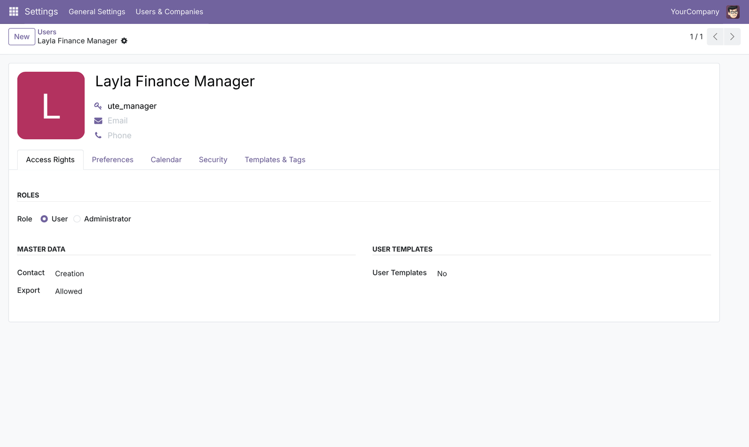

2.4 Menus
All menus sit under Settings → Users & Companies → User Templates and are visible to User Template Managers only.
Menu | Opens
User Templates | List and forms of templates
User Tags | List and forms of tags
Bulk Apply Templates | The bulk application wizard
Application Log | History of every applied change

2.5 Scheduled action
The module ships one scheduled action, User Templates: re-synchronise all users, inactive by default. When active, it runs once a day and re-applies every applicable template to every user, which corrects manual drift. Odoo 19 has no Number of Calls limit: an active scheduled action repeats until it is deactivated.
To activate it: developer mode on, then Settings → Technical → Automation → Scheduled Actions, open the action, tick Active, adjust the interval if needed and save.

3. Key concepts
Each user receives a stack of templates, applied in sequence order; each template sets some settings, and for each setting decides where the value comes from (policy) and how it combines with the user's current value (mode).
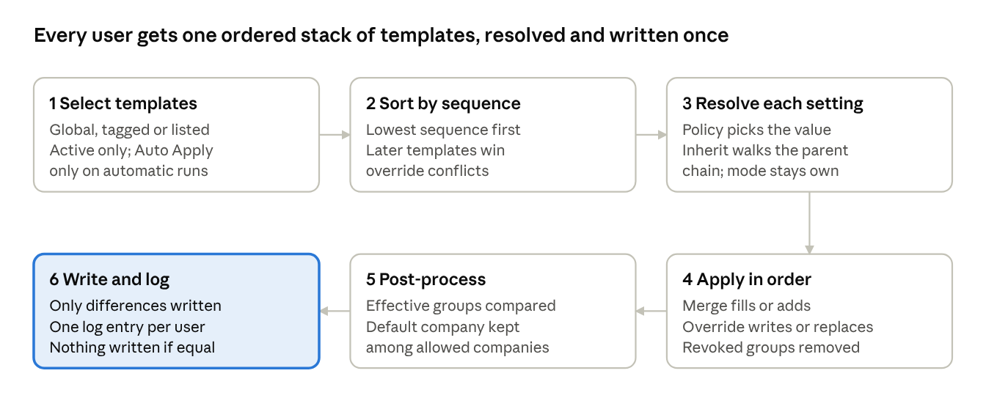
template resolution · 6 steps per user
Steps 1 to 5 only compute; the user record changes once, in step 6, and only where the result differs. The wizard preview shows the outcome of step 5 without writing.

3.1 Glossary
Term | Meaning
Template | A named bundle of settings (language, time zone, home action, companies, groups) plus targeting and behaviour options
Global template | Applies to every internal user (optionally portal users too)
Targeted template | Applies only to users carrying one of its tags, or listed explicitly
User tag | A label that groups users logically, e.g. Finance Team
Parent template | The template a child takes inherited values from
Sequence | The application order; lower runs first, higher wins conflicts
Policy | Where a setting's value comes from
Mode | How the value combines with the user's existing value
Explicit groups | Groups assigned directly to the user (group_ids)
Effective groups | Explicit groups plus every group they imply (all_group_ids)
Plan | The computed list of changes for one user, before anything is written
Application log | The permanent record of every applied plan

3.2 Policies
Every managed setting has its own policy.
Policy | Effect
Not Managed | The template ignores this setting (default)
Set on this Template | The value entered on this template is used
Inherit from Parent | The value is taken from the parent template; if the parent also inherits, the search continues up the chain until a template sets it or does not manage it

3.3 Modes
Mode | Single-value settings (language, time zone, home action, default company) | List settings (allowed companies, access groups)
Merge (Additive) | Written only if the user has no value yet | Added to the user's current list
Override (Strict) | Always written | Replaces the user's list
Template Default | Uses the template's Apply Mode | Uses the template's Apply Mode
Revoked groups have no mode: they are always removed.

3.4 Precedence in one sentence
Templates run from the lowest to the highest Sequence; for override settings the last writer wins, for merge settings the first non-empty value stays, and revocations always subtract.

4. User tags
Tags group users by team, role or status so templates can target them. Adding or removing a tag on a user immediately re-applies that user's auto-apply templates.
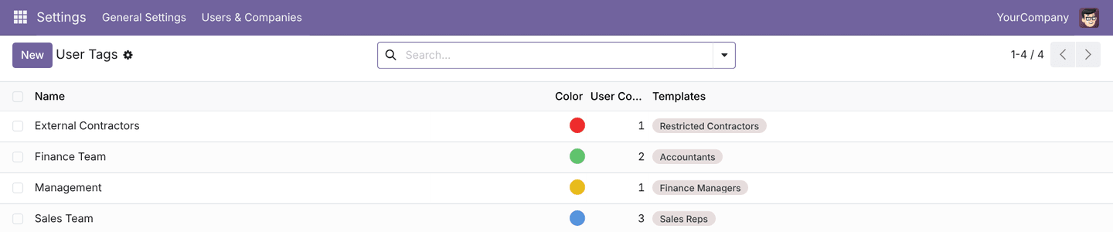

4.1 Tag fields
Field | Description
Name | Unique tag name, e.g. Finance Team
Color | Colour of the tag chip on users and templates
Templates | Templates that target this tag (also editable from the template)
Description | Free notes
Users | The users carrying the tag
Active | Unticked = archived; archived tags are hidden but kept on users

4.2 Create a tag
- Go to Settings → Users & Companies → User Templates → User Tags.
- Click New.
- Enter the Name and pick a Color.
- Optionally link Templates and add Users with Add a line.
- Save. The Users smart button shows the member count.
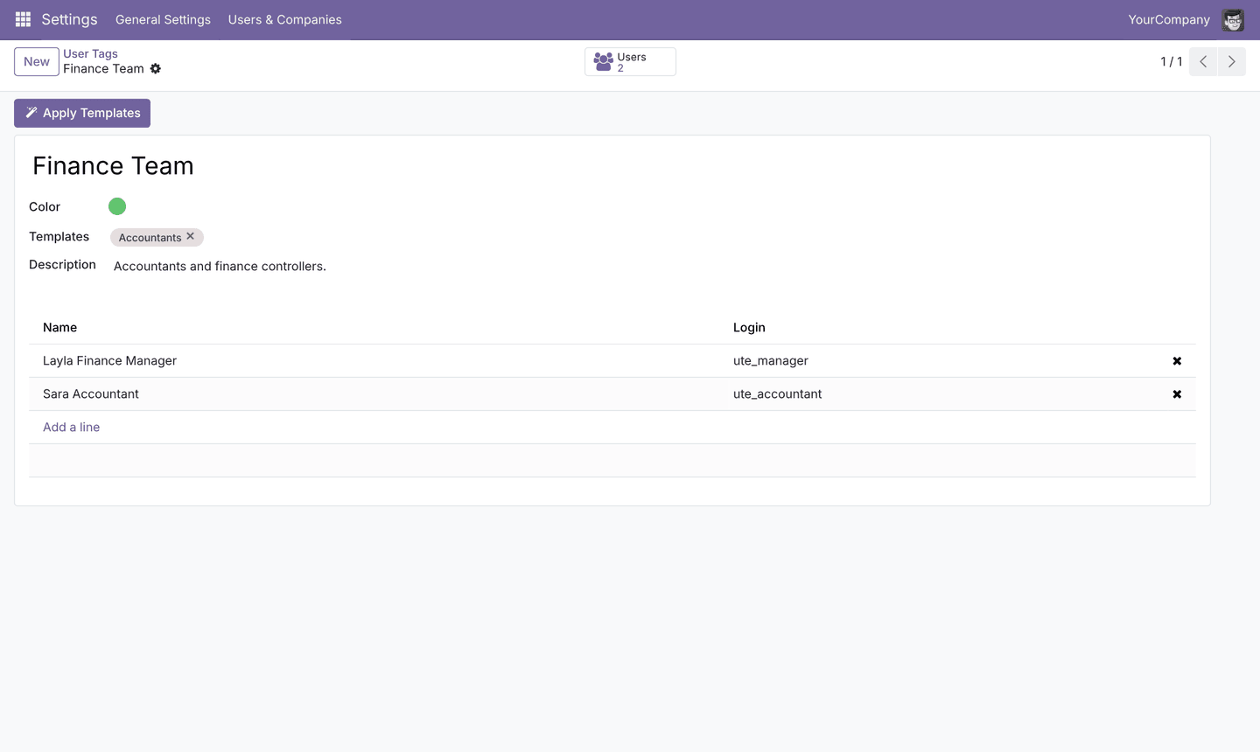

4.3 Tag users
Use whichever is faster; both trigger auto-apply templates.
- From the tag: open the tag and add or remove lines in the users list.
- From the user: open the user, tab Templates & Tags, field User Tags.
- From the users list: the User Tags column shows each user's tags next to Odoo 19's Role column; use Group By → User Tags in the search bar to review membership.
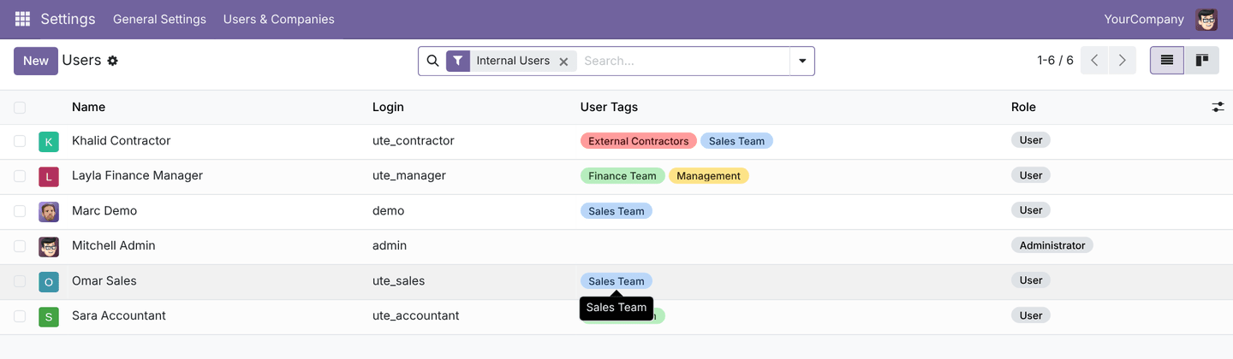
Only User Template Managers can edit tags on users. This prevents a user with partial rights from gaining access by tagging themselves.

5. User templates
A template is configured on one form: the header sets who it targets and how it behaves, and the tabs set each managed setting with its policy and mode.
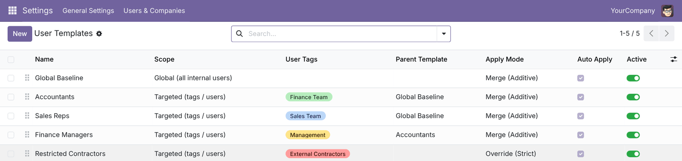
The list is ordered by Sequence; drag the handle on the left to reorder. The Active toggle archives a template, which the engine then ignores.

5.1 Header fields
Field | Description | Default
Name | Template name | —
Scope | Global (all internal users) or Targeted (tags / users) | Targeted
Include Portal | Global only: also apply to portal users (preferences only, never groups) | Off
User Tags | Targeted only: users carrying any of these tags receive the template | —
Owner Company | Multi-company only: restricts the template to users allowed in this company, and hides it in other companies | Empty
Sequence | Application order; higher = applied later = wins override conflicts | 10
Apply Mode | Default mode for every setting left on Template Default: Merge or Override | Merge
Parent Template | Template that inherited values come from | Empty
Auto Apply | Apply automatically on user creation and tag changes | On
Protect Admins | Never change the groups of users with the Administrator role | On
Smart buttons: Targeted Users lists the users this template reaches; Child Templates lists templates that inherit from it. Apply to Users opens the bulk wizard pre-filled with this template.

5.2 Preferences tab
Language, Timezone and Home Action, each with a Policy and, unless Not Managed, a Mode. The value field appears when the policy is Set on this Template. Only installed languages can be chosen.
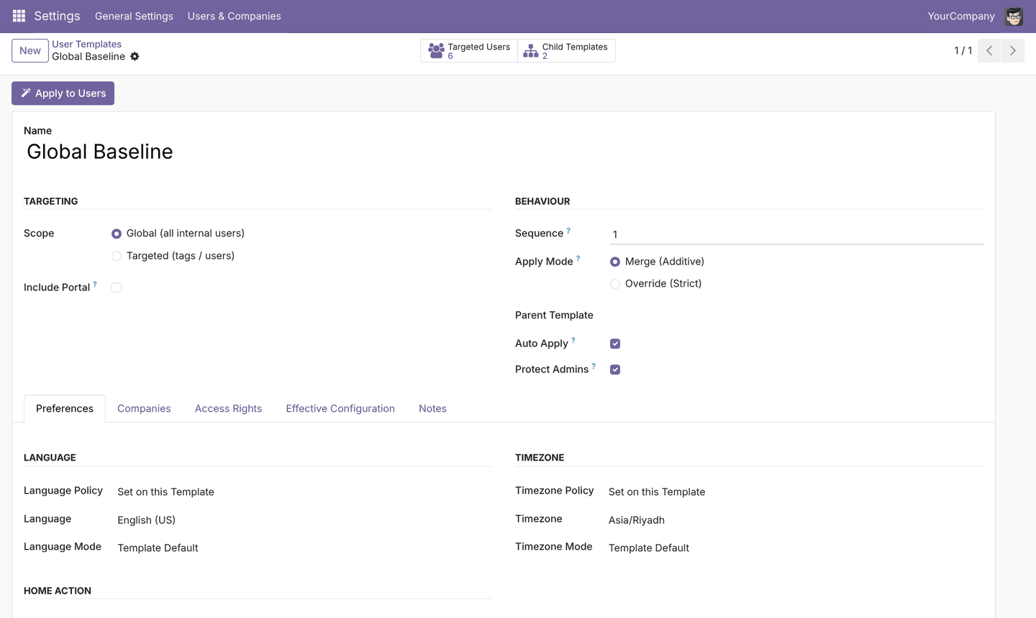

5.3 Companies tab
Allowed Companies (list) and Default Company (single value), each with policy and mode. When both are set on the same template with override, the default company must be one of the allowed companies, or the template cannot be saved.
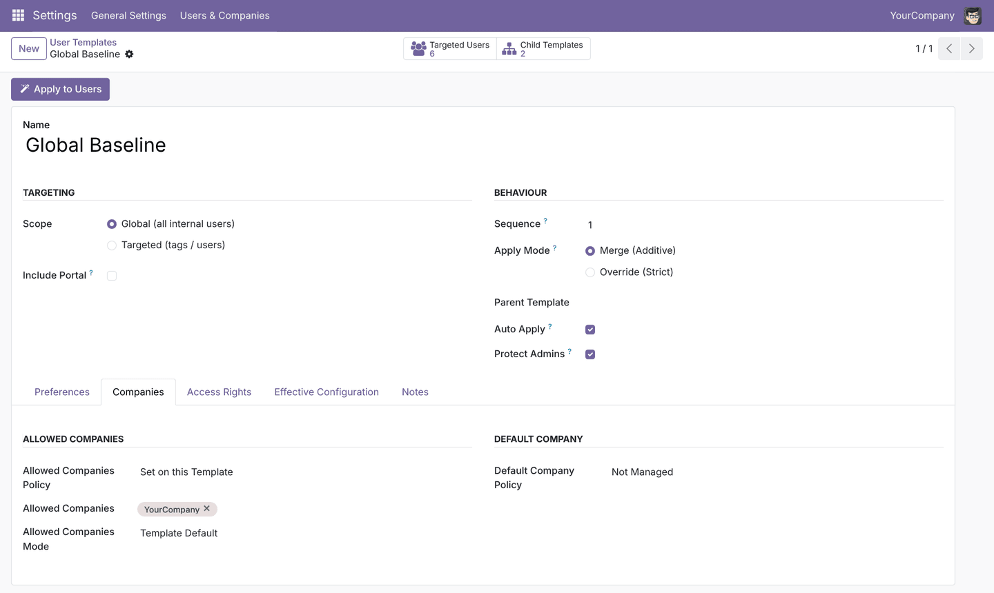

5.4 Access Rights tab
Block | Fields | Notes
Granted Groups | Policy, Mode, list of groups | Merge adds the groups; override replaces the user's explicit groups (the user type is always kept)
Revoked Groups | Policy, list of groups | Removed after this template's own grants; no mode
Internal User, Portal and Public cannot be selected in either list. Groups are listed with their Odoo 19 names, e.g. Contact / Creation, Export / Allowed. A revoked group that is still implied by another group the user keeps stays effective, which is standard Odoo behaviour.
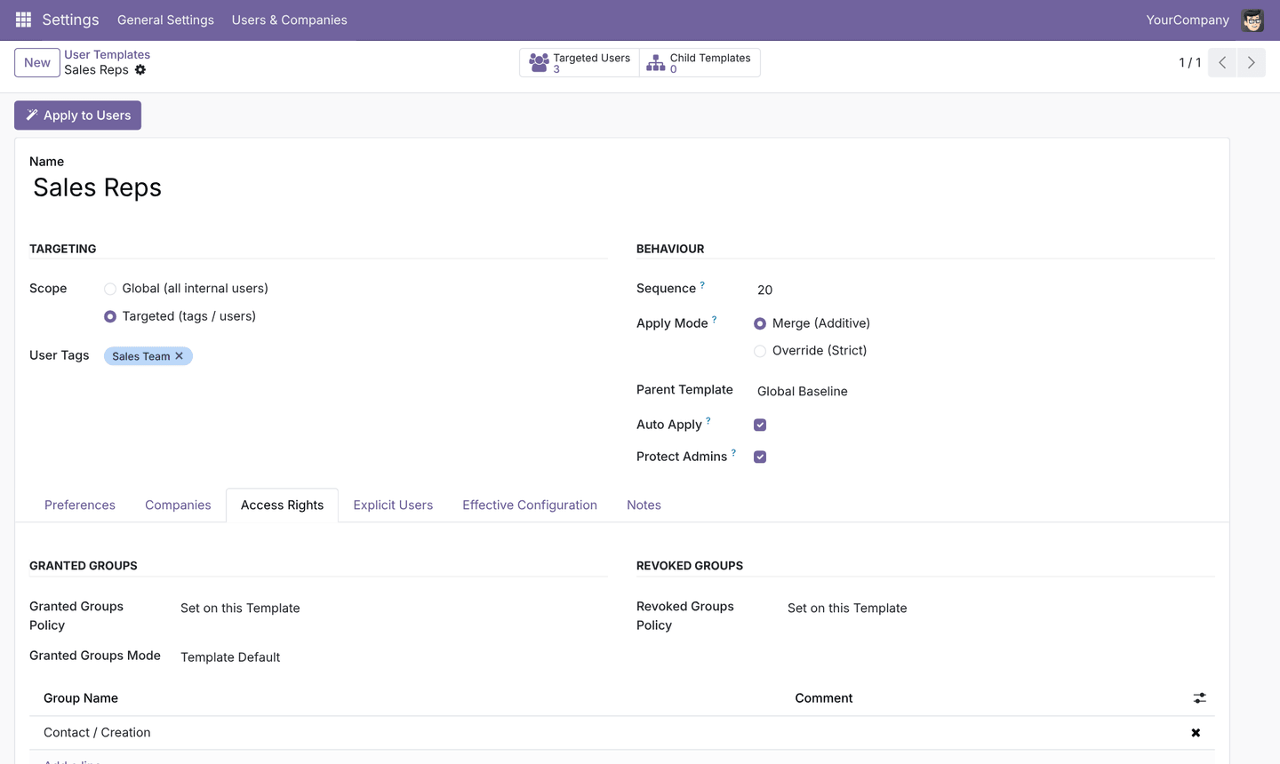

5.5 Explicit Users, Effective Configuration and Notes tabs
- Explicit Users (targeted templates only): users who receive the template whatever their tags.
- Effective Configuration: read-only table of every setting after inheritance, with its mode and the template the value comes from. Save the template to refresh it. See section 7.2.
- Notes: free description of the template's purpose.

5.6 Create a template step by step
- Go to Settings → Users & Companies → User Templates → User Templates and click New.
- Enter the Name.
- Choose the Scope. For targeted templates, add User Tags and/or users in Explicit Users.
- Set the Sequence: low (e.g. 1) for a baseline, higher (20, 30) for functional templates, highest (90) for restrictive overrides.
- Choose the Apply Mode: Merge to add on top of users' current settings, Override to enforce an exact configuration.
- Optionally choose a Parent Template.
- In each tab, set the Policy of the settings you want to manage, enter the value, and change the Mode only where it should differ from the Apply Mode.
- Save, then check the Effective Configuration tab.
- Click Targeted Users to confirm the audience, then Apply to Users to preview and apply (section 6.3).

6. Applying templates
Templates reach users in five ways; the three automatic ones use only templates with Auto Apply ticked, the manual ones use all applicable active templates.
Trigger | When | Templates used | Log trigger
User creation | A user is created (form, import, signup) | Auto Apply templates targeting the user | User Creation
Tag change | Tags change on a user or on a tag | Auto Apply templates targeting the user | Tag Change
Apply Templates Now | Button on the user form | All applicable templates | Manual
Bulk wizard | Wizard opened from a menu, button or Actions menu | All applicable, or only the selected templates | Bulk Wizard
Scheduled sync | Daily, if the scheduled action is active | All applicable templates | Scheduled Sync
Editing a template does not change users by itself. After changing a template, apply it with Apply to Users or wait for the scheduled sync.

6.1 Apply to one user
- Open the user (Settings → Users & Companies → Users).
- Open the Templates & Tags tab.
- Click Apply Templates Now. A notification says whether the user changed.

6.2 Open the bulk wizard
- Settings → Users & Companies → User Templates → Bulk Apply Templates, or
- Apply to Users on a template form (pre-fills the template), or
- Apply Templates on a tag form (pre-fills the tag), or
- select rows in the users or tags list, then Actions → Apply User Templates.
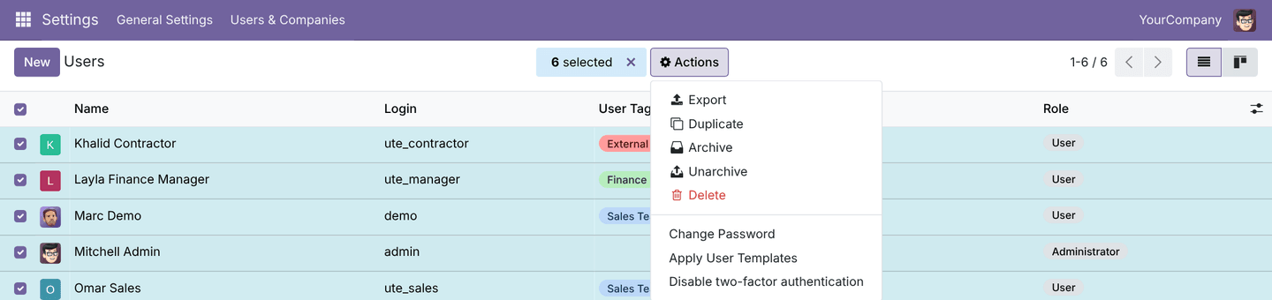

6.3 Use the bulk wizard
- Under Who, choose the Target:
  - Selected Users: the users you pick.
  - Users with Tags: every user carrying one of the chosen tags.
  - Audience of Selected Templates: every user the chosen templates target.
  - All Active Users: everyone except the superuser.
- Under What, choose the Strategy:
  - Resolve all applicable templates (recommended): each user gets their full stack of templates in sequence order.
  - Apply only the selected templates: only the chosen templates, in sequence order, even for users they do not target.
- Read Users in Scope and the Preview of changes (dry run) table: one row per user and setting, with before (red) and after (green) values and the templates involved. Group changes are shown as effective groups. Nothing is written yet.
- Click Apply. A notification reports how many users changed; users who already match are skipped.
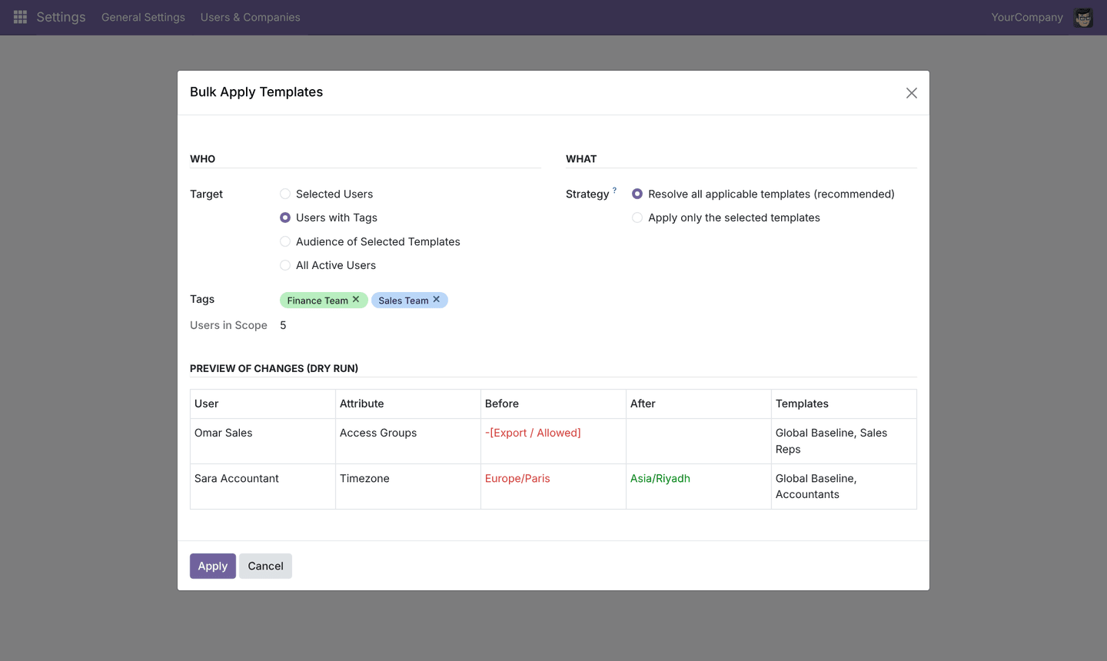
The preview shows the first 50 users when the scope is larger; Apply still processes every user in scope.

6.4 When to choose which strategy
Situation | Target | Strategy
A new template was created or edited | Audience of Selected Templates | Resolve all applicable templates
A team's settings drifted after manual edits | Users with Tags | Resolve all applicable templates
One-off: give a template to users it does not target | Selected Users | Apply only the selected templates
Full clean-up after configuration changes | All Active Users | Resolve all applicable templates

7. Monitoring and auditing
Three screens answer the three support questions: which templates reach this user, what a template really sets after inheritance, and what changed, when and by whom.

7.1 Templates & Tags tab on the user
On every user form, managers see a Templates & Tags tab (after Access Rights, Preferences, Calendar and Security) with:
- User Tags, editable.
- Apply Templates Now button.
- Applicable Templates (precedence order): every active template reaching this user, lowest sequence first.
- History: the user's log entries, newest first.
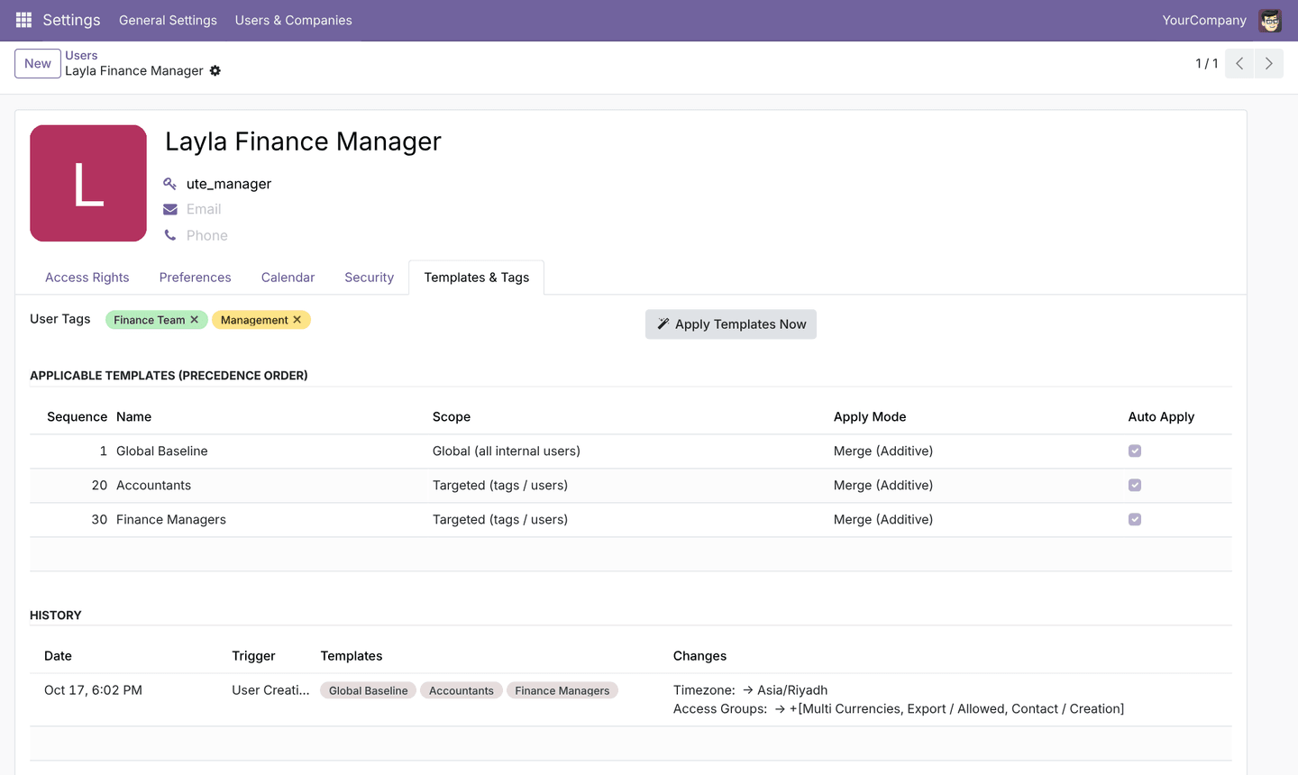

7.2 Effective Configuration tab on the template
The table lists each of the seven settings with its resolved value, the mode used and the Value Source, the template that actually supplies it. Use it to check inheritance before applying.
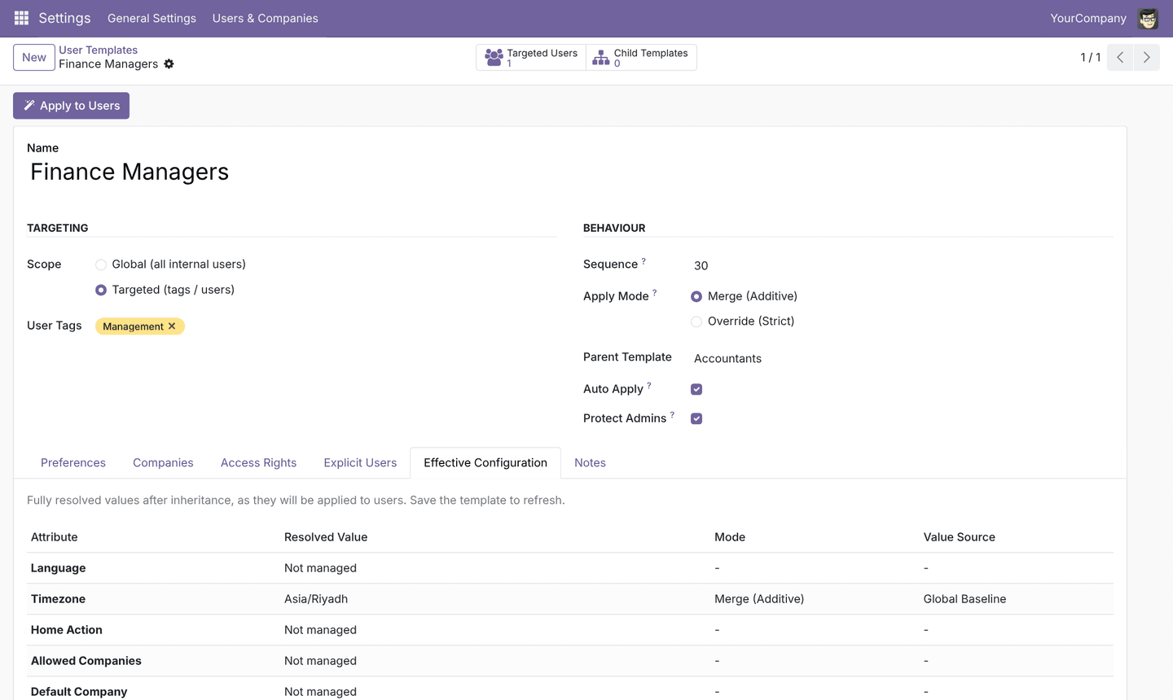
If the tab shows a red message about recursive inheritance, a parent chain loops back on itself; fix the Parent Template fields.

7.3 Application log
Settings → Users & Companies → User Templates → Application Log lists one entry per user per application.
Column | Content
Date | When the change was written
User | The user who changed
Trigger | User Creation, Tag Change, Bulk Wizard, Manual or Scheduled Sync
Templates | Templates that changed something for this user
Applied By | The person who triggered it (System for automatic runs)
Changes | One line per setting: before → after; for groups, the effective groups -[removed] and +[added]
Use Group By → User or Trigger to review history. Entries cannot be edited; managers can delete them. Applying templates that are already in place writes nothing and creates no entry.
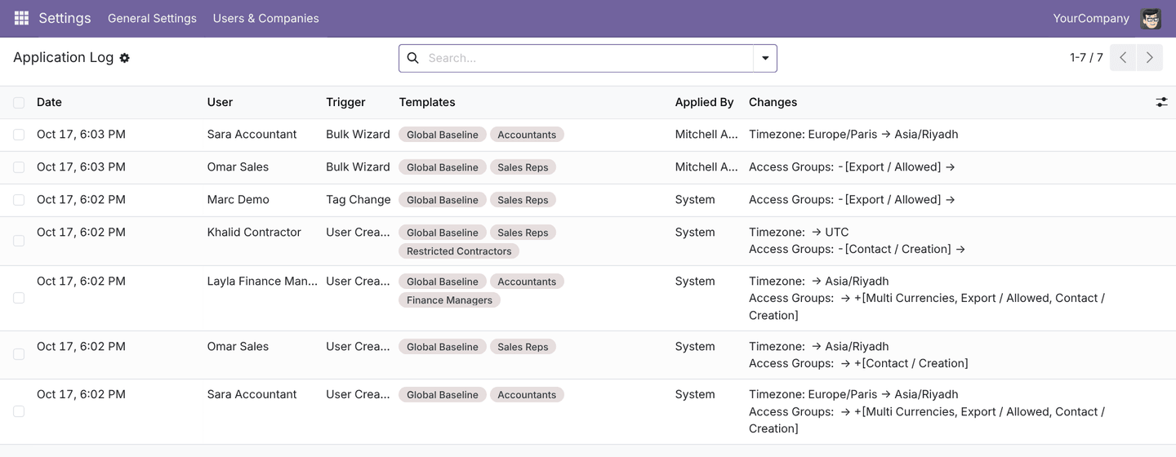

8. Resolution rules and safeguards
For each user the engine computes a complete plan in memory, then writes it in one operation; the same inputs always give the same result.

8.1 Resolution order
- Select templates. Active templates are kept if they are global (internal users; portal too with Include Portal), or if the user carries one of their tags or is listed explicitly. A template with an Owner Company is kept only if the user is allowed in that company. Automatic triggers keep only Auto Apply templates.
- Sort by Sequence, then by creation order.
- Resolve each template. For every setting: Not Managed skips it; Set on this Template takes its value; Inherit from Parent walks up the parents. The mode is always the applied template's own.
- Apply in order to a copy of the user's current settings, using the merge and override rules of section 3.3. Revoked groups are removed after the template's grants.
- Post-process. Group changes are kept only if the user's effective groups change (section 8.4); the default company is made consistent with the allowed companies.
- Compare and write. Only settings that differ are written. Users with identical changes are written together. One log entry is created per changed user.

8.2 Conflict examples
Templates (sequence, mode) | User before | Result | Why
Baseline (1, merge) tz Riyadh | tz Brussels | Brussels | Merge never overwrites an existing value
Baseline (1, merge) tz Riyadh; Accountants (20, override, inherits tz) | tz Paris | Riyadh | Accountants overrides with the inherited value
Baseline (1, override) tz London; Finance (20, override) tz Riyadh | tz UTC | Riyadh | The higher sequence writes last
Baseline (1, merge) grants Export / Allowed; Sales Reps (20) revokes it | no Export | no Export | The revocation runs after the earlier grant
Sales Reps (20, merge) grants Contact / Creation; Contractors (90, override) grants nothing | Contact / Creation | Internal User only | The override at 90 replaces all earlier grants

8.3 Built-in safeguards
Safeguard | Behaviour
User type protection | Internal User, Portal and Public groups cannot be selected in templates and are kept on every override
Admin protection | With Protect Admins on, groups of users with the Administrator role are never changed; their preferences still apply
Portal users | Never receive or lose access groups, even with Include Portal
Superuser | The technical superuser (OdooBot) is never processed
Companies | A user is never left without companies; an enforced default company is added to the allowed companies; otherwise the first allowed company becomes the default
Inheritance loops | Saving a parent chain that loops is refused
Inherit without parent | A template with an Inherit from Parent policy must have a Parent Template
Idempotency | Re-applying the same templates changes nothing and logs nothing
Privilege escalation | Only managers can edit user tags and apply templates

8.4 Explicit and effective groups (Odoo 19)
Odoo 19 stores only the groups assigned directly to a user (explicit, group_ids) and computes everything they imply (effective, all_group_ids). The module follows that model:
- Grants, overrides and revocations edit the user's explicit groups only. Implied groups are never written as explicit ones.
- A group change is written only when the user's effective groups differ afterwards. Adding a group the user already has through another group, or revoking a group that another kept group still implies, is treated as no change.
- The preview and the log show the change in effective groups, which is what the user can actually do.

9. Worked example: the demo data
The demo data models a small company with one baseline, three functional templates and a strict contractor template; installing it on Odoo 19 (with demo data enabled) shows every rule of section 8 at work.

9.1 Templates
Sequence | Template | Scope / tags | Parent | Mode | Main settings
1 | Global Baseline | Global | — | Merge | Language English, time zone Asia/Riyadh, main company, grants Export / Allowed
20 | Accountants | Finance Team | Global Baseline | Merge | Inherits time zone with Override, inherits companies, grants Multi Currencies and Contact / Creation
20 | Sales Reps | Sales Team | Global Baseline | Merge | Inherits time zone, grants Contact / Creation, revokes Export / Allowed
30 | Finance Managers | Management | Accountants | Merge | Inherits time zone and groups through two levels
90 | Restricted Contractors | External Contractors | — | Override | Time zone UTC, groups replaced by nothing
50 | Legacy Template (archived) | Global | — | Override | Ignored because archived
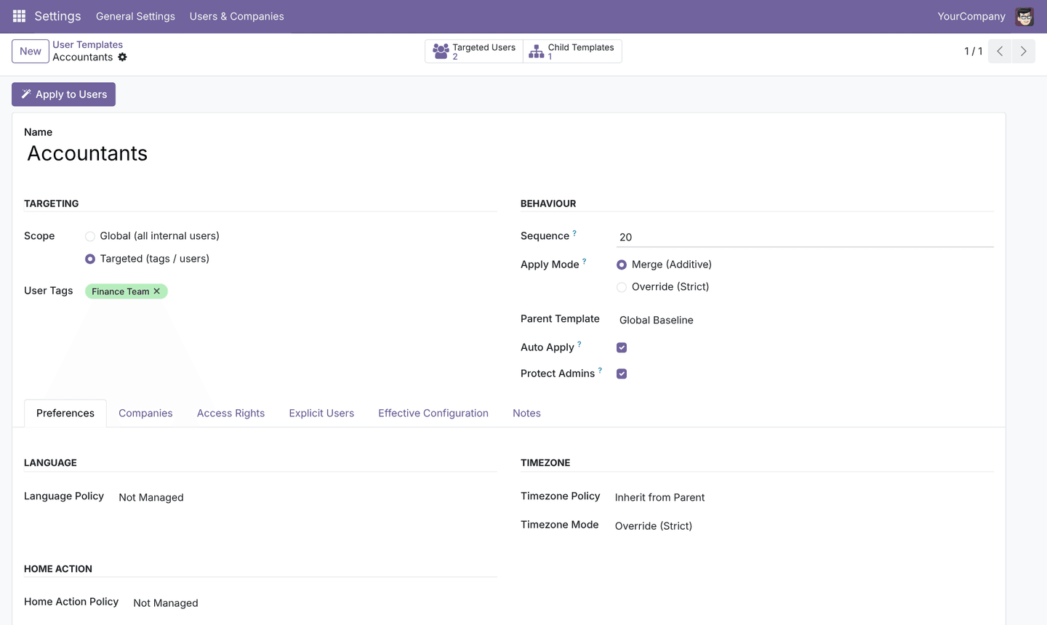
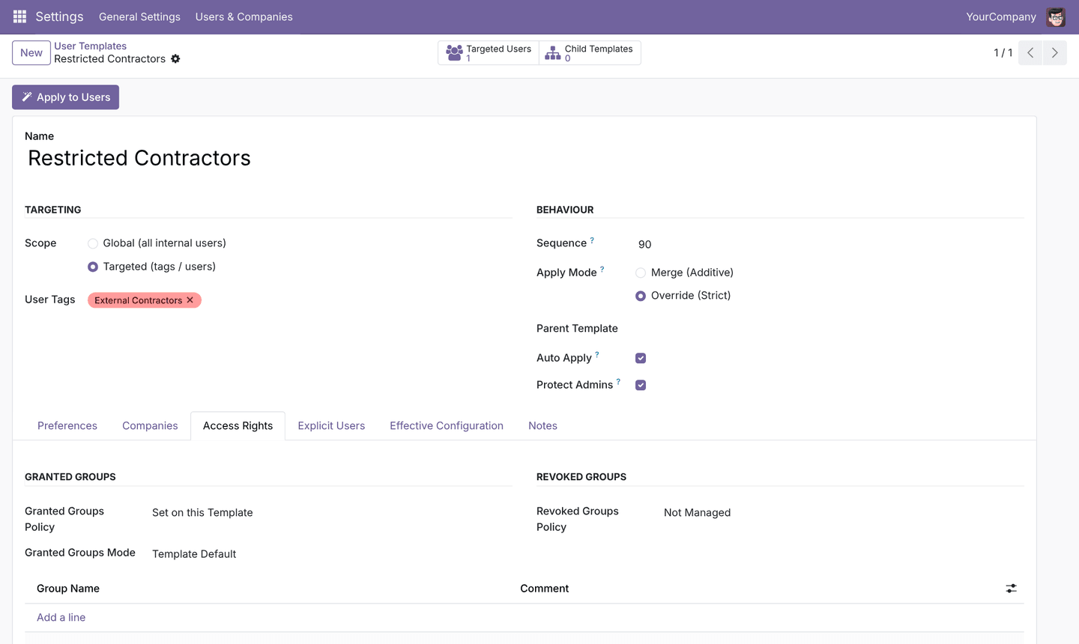

9.2 Users and results
User (login = password) | Tags | Before | After
Sara Accountant (ute_accountant) | Finance Team | tz Europe/Paris | tz Asia/Riyadh; Export / Allowed, Multi Currencies, Contact / Creation
Omar Sales (ute_sales) | Sales Team | no tz | tz Asia/Riyadh; Contact / Creation; no export
Layla Finance Manager (ute_manager) | Finance Team, Management | no tz | tz Asia/Riyadh; same groups as Accountants
Khalid Contractor (ute_contractor) | Sales Team, External Contractors | Contact / Creation | tz UTC; Internal User only
Marc Demo (demo) | Sales Team | tz Europe/Brussels, Export / Allowed | tz Brussels kept (merge); export revoked
Mitchell Admin (admin) | — | Administrator role | Groups untouched (Protect Admins); tz kept

9.3 Try it yourself
- Open Sara Accountant and set her Timezone to Europe/Paris in the Preferences tab; save.
- Open Bulk Apply Templates, target Users with Tags, select Finance Team and Sales Team.
- The preview shows Sara going back to Asia/Riyadh. Click Apply.
- Open Application Log: a Bulk Wizard entry records the change.
- Add the tag External Contractors to Omar Sales: his groups drop to Internal User immediately and a Tag Change entry appears.

10. Troubleshooting and FAQ
Most support questions are answered by the user's Templates & Tags tab, the template's Effective Configuration tab and the Application Log, in that order.

10.1 Troubleshooting
Symptom | Likely cause | What to do
Installation fails, the module is marked not installable, or errors mention groups_id | An Odoo 18 or 17 package was installed on Odoo 19 | Remove it and install base_user_template_engine_v19.zip (version 19.0.x), then Update Apps List
No demo tags, templates or users after installation | The database was created without demo data (Odoo 19's default) | Use a database created with Demo data ticked, or --with-demo; demo data cannot be added to an existing production database
A group I granted does not appear in the user's explicit groups | The user already had it through another group | Intended: the effective result was unchanged, so nothing was written (section 8.4)
I edited a template but users did not change | Editing a template never changes users by itself | Click Apply to Users on the template, or activate the scheduled sync
A new user did not receive a template | Auto Apply is off, the template is archived, or the user has none of its tags | Check the template's Auto Apply and Active; check the user's tags; then Apply Templates Now
A template's time zone is ignored for some users | The setting is in Merge mode and those users already have a time zone | Set the setting's Mode to Override, then apply
A revoked group is still effective on the user | Another group the user keeps implies it | Revoke the implying group too, or remove it from the granting template
An administrator's groups did not change | Protect Admins is on | Intended; untick it on that template only if you really want to change admin groups
A portal user did not receive groups | Portal users never receive access groups | Intended; change the user type manually if needed
The default company changed unexpectedly | Allowed companies were overridden and no longer contained the old default | Also manage Default Company on the template
Error "Template inheritance cannot be recursive" | The parent chain loops | Fix the Parent Template of one template in the loop
Error "... inherits ... but has no parent template" | A policy is Inherit from Parent without a parent | Choose a Parent Template or change the policy
Error "User type groups ... cannot be managed by templates" | Internal User, Portal or Public was added | Remove it; the user type is managed by Odoo
Error "the default company must be one of the allowed companies" | Same template overrides allowed companies without its default company | Add the default company to Allowed Companies
Error "A user tag with this name already exists" | Tag names are unique | Use a different name, or reuse the existing tag
The menus are not visible | The user is not a User Template Manager | On the user, Access Rights tab, set User Templates to User Template Manager
A user can't edit User Tags | Only managers can edit tags | Intended; ask a manager
The language I want is not in the list | The language is not installed | Install it in Settings → Languages first

10.2 Frequently asked questions
Does the module replace Odoo's default user groups or the Role field? No. Odoo still gives new internal users its default groups and a Role; auto-apply templates then run on top.
Can a user receive several templates? Yes. Every applicable template is applied, in sequence order; see section 8.
What happens when I remove a tag from a user? The user's remaining auto-apply templates are re-applied. Groups granted only by the removed template stay unless a remaining template overrides or revokes them.
Can I preview a change without applying it? Yes. The bulk wizard always shows a dry-run preview before Apply.
Does archiving a template undo what it applied? No. Archiving only stops future applications. Use an override or revoking template to remove rights.
Is it safe to activate the daily sync? Yes. Users who already match produce no write and no log entry. Make sure templates are correct first, because the sync enforces them on everyone.
Does it work with multiple companies? Yes. Templates can manage allowed and default companies, and an Owner Company limits a template to one company's users.
I am upgrading a database from Odoo 18. Do my templates carry over? The module's own tables and fields are unchanged between the two editions, so templates, tags and log entries need no conversion. After the database is upgraded to Odoo 19, replace the module folder with the Odoo 19 package and update the module.

11. Technical reference
The module adds four models, extends res.users, and keeps all engine logic in res.users.template._apply_to_users(). Section 11.7 lists every change from the Odoo 18 edition.

11.1 Models
Model | Type | Purpose | Key fields
res.users.template | Model | A template | scope, tag_ids, user_ids, sequence, apply_mode, parent_id, auto_apply, protect_admins, company_id, and for each setting <setting>, <setting>_policy, <setting>_mode
res.users.tag | Model | User grouping; unique name via models.Constraint | name, color, user_ids, template_ids
res.users.template.log | Model | Audit trail | user_id, template_ids, trigger, changes, create_date, create_uid
res.users.template.apply.wizard | Transient | Bulk application | target, user_ids, tag_ids, strategy, template_ids, preview_html
res.users | Extended | Tags and history on users | tag_ids, applicable_template_ids (computed), template_log_ids
Managed settings on res.users.template: lang, tz, home_action_id, allowed_company_ids, default_company_id, group_ids, group_remove_ids. Group settings are written to the user's explicit group_ids and compared through all_group_ids / res.groups.all_implied_ids.

11.2 Relation tables
Table | Links
res_users_tag_user_rel | users ↔ tags
res_users_template_tag_rel | templates ↔ tags
res_users_template_user_rel | templates ↔ explicit users
res_users_template_group_rel | templates ↔ granted groups
res_users_template_group_remove_rel | templates ↔ revoked groups
res_users_template_company_rel | templates ↔ allowed companies
res_users_template_log_rel | log entries ↔ templates

11.3 ORM hooks and entry points
Method | Role
res.users.create() | After creation, applies auto-apply templates (trigger create)
res.users.write() | When tag_ids changes, re-applies auto-apply templates (trigger tag_change)
res.users.tag.write() | When user_ids changes, re-applies for added and removed users
res.users.template._apply_to_users(users, templates=None, trigger, dry_run, auto_only) | The engine: returns {user_id: plan}; writes and logs unless dry_run
res.users.template._get_effective_values() | Resolved settings of one template after inheritance
res.users.template._get_user_type_groups() | Delegates to Odoo 19's res.groups._get_user_type_groups()
res.users.template._cron_apply_all() | Scheduled sync entry point
Context key skip_user_template_engine=True disables the automatic hooks, for example in data migrations.

11.4 Security
Record | Definition
Privilege res_groups_privilege_user_template | User Templates, in category User Templates; shows the group on the user form
Group group_user_template_manager | privilege_id above; implies base.group_erp_manager; implied by base.group_system
Access, templates and tags | Managers: full; Access Rights: read
Access, log | Managers: read and delete
Access, wizard | Managers: full
Record rule | Templates visible when company_id is empty or in the user's companies
Field restriction | res.users.tag_ids and history fields: managers only

11.5 Data files
File | Content
security/security.xml | Category, privilege, manager group, multi-company rule
security/ir.model.access.csv | Access rights
data/ir_cron.xml | Daily re-sync, inactive (noupdate)
views/*.xml | Template, tag, log and user views, menus
wizard/*_views.xml | Wizard form and Actions-menu bindings (group_ids)
demo/user_template_demo.xml | Demo tags, templates and users (loaded only with demo data)
static/description/ | App store page, icon, banner, Odoo 19 screenshots

11.6 Automated tests
Run the 26 TransactionCase tests with:
odoo-bin -d <database> -i base_user_template_engine --test-enable --test-tags /base_user_template_engine --stop-after-init
They cover targeting, archived templates, override and merge precedence, a full multi-template conflict stack, groups merge, override and revocation, user-type and admin protection, portal users, multi-level inheritance, cycle detection, company consistency, automatic application on creation and tag change, the bulk wizard (including its live preview), idempotency and language application. Group assertions check effective groups (all_group_ids). All 26 pass on Odoo 19.0.

11.7 Differences from the Odoo 18 edition
Area | Odoo 18 edition | Odoo 19 edition | Reason
Manifest version | 18.0.1.0.0 | 19.0.1.0.0 | Version series must match the server
User groups field | res.users.groups_id (all groups) | group_ids (explicit) + all_group_ids (effective) | Renamed and split in Odoo 19
Engine group logic | Compares the implied-closed set | Edits explicit groups; writes only if effective groups change | Avoids writing implied groups as explicit and keeps re-runs idempotent
Implied groups | res.groups.trans_implied_ids | res.groups.all_implied_ids (includes the group itself) | Renamed in Odoo 19
User type groups | Groups in category base.module_category_user_type | res.groups._get_user_type_groups() | The category no longer exists
Manager group | category_id on the group | privilege_id → new res.groups.privilege record | Odoo 19 shows groups on the user form through privileges
Group members | users | user_ids | Renamed in Odoo 19
Window action groups | groups_id | group_ids | Renamed in Odoo 19
Unique tag name | _sql_constraints | models.Constraint | Odoo 19 ignores _sql_constraints (warning only), so the constraint would silently disappear
Search view group-by block | <group expand="0" string="Group By"> | <group> | Odoo 19 core style
Demo data | Loaded by default | Needs Demo data / --with-demo | Odoo 19 default changed
Tests | groups_id | group_ids for writes, all_group_ids for checks | Field split
Unchanged | Views (<list>, invisible=), wizard, cron, ACLs, record rule, _() translations, _tz_get, get_installed, _is_system | Same | Still valid in Odoo 19

